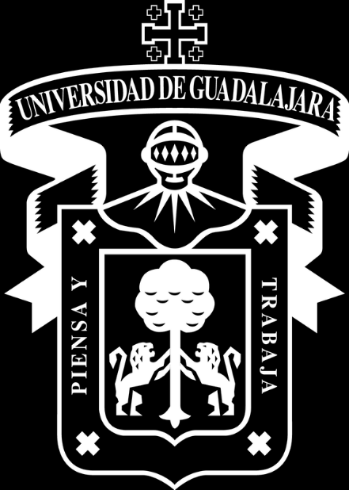

Práctica 3

Juego de Plataformas 3D con Colección de Monedas

Arturo Daniel Agredano Gutiérrez

222966871

Programacion de gráficos 3D

D02

Jose Luis David Bonilla Carranza

01/11/2025

## Capturas del desarrollo

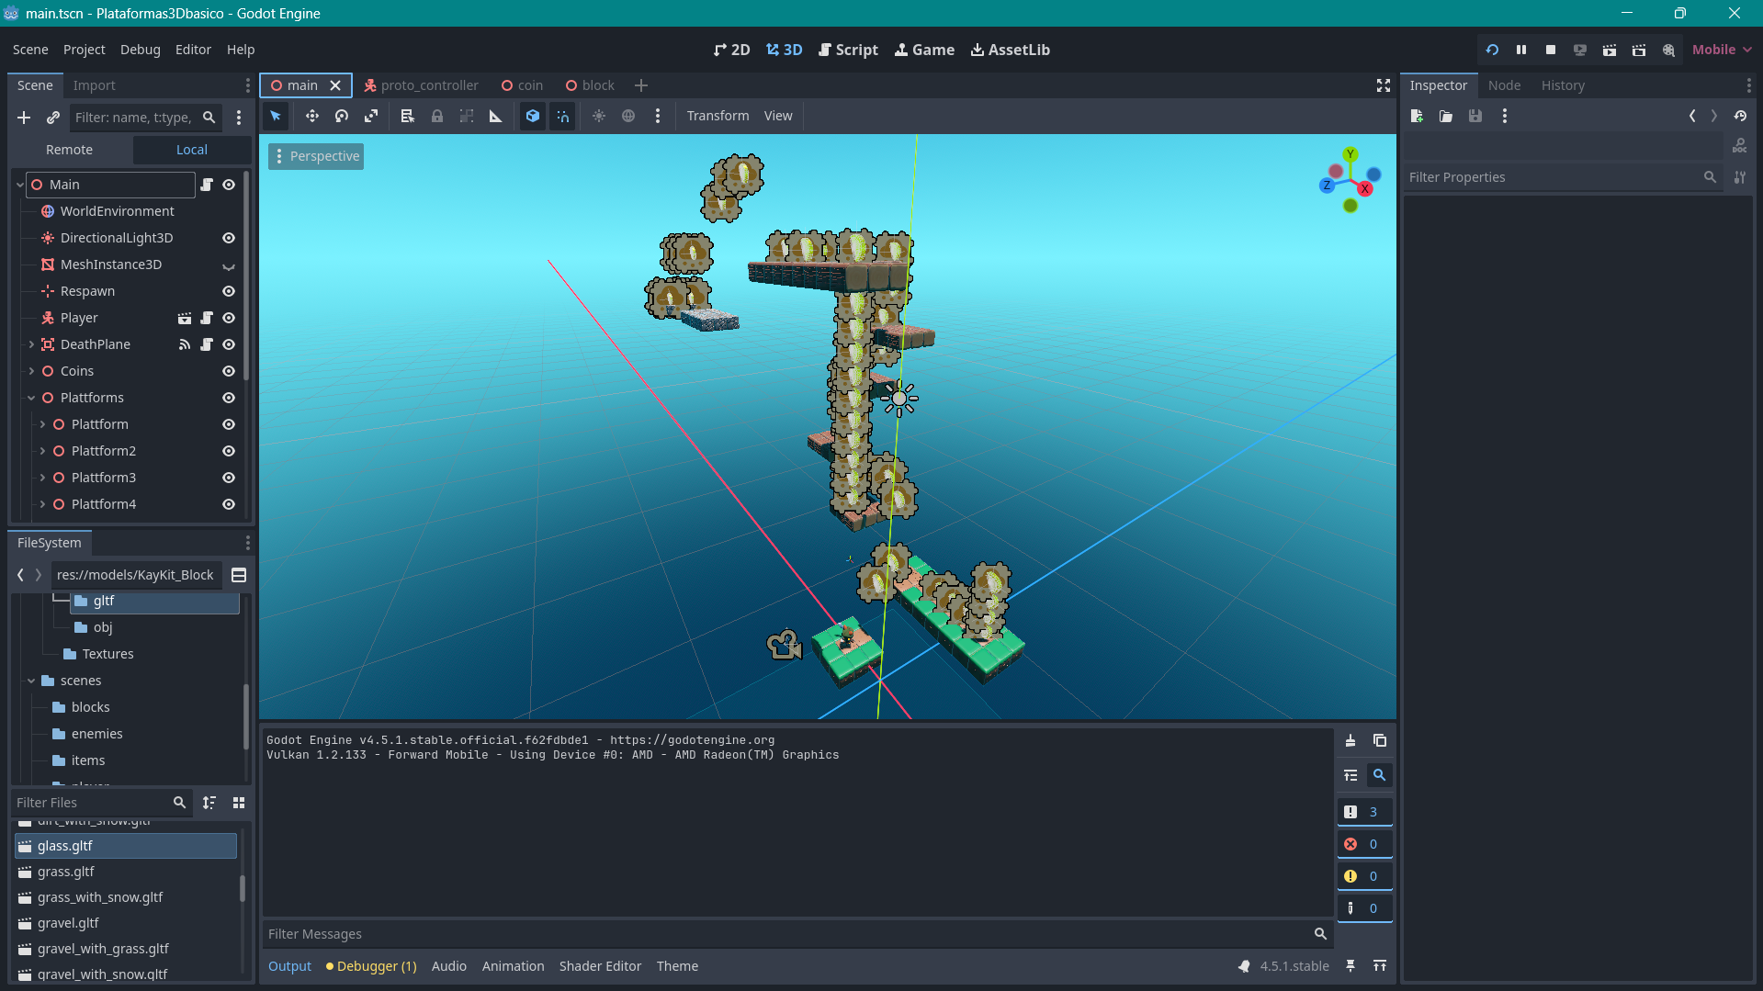

Escena del nivel

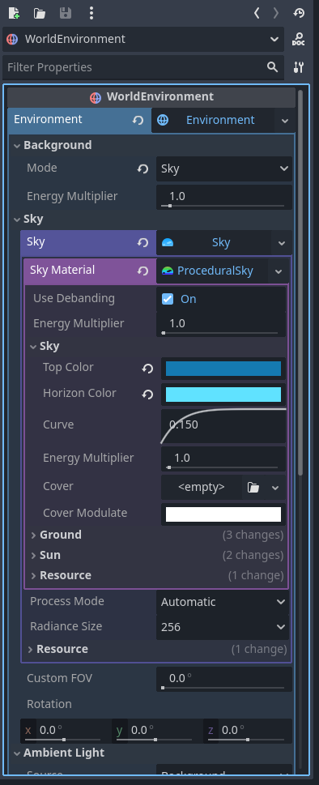

Configuración del ambiente

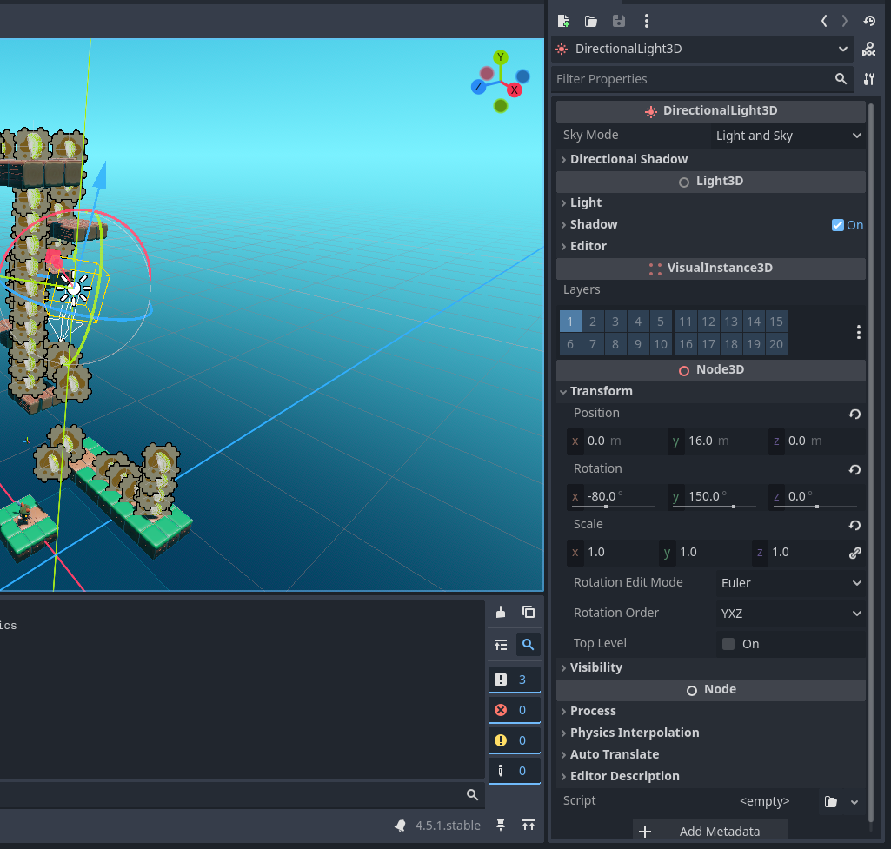

Configuración de la luz global

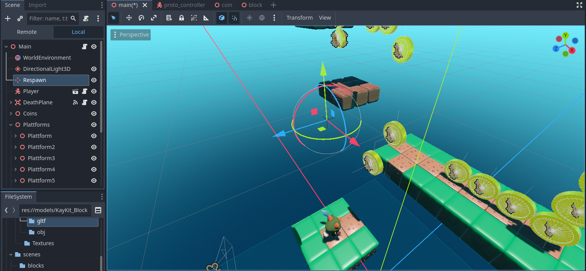

Punto de respawn

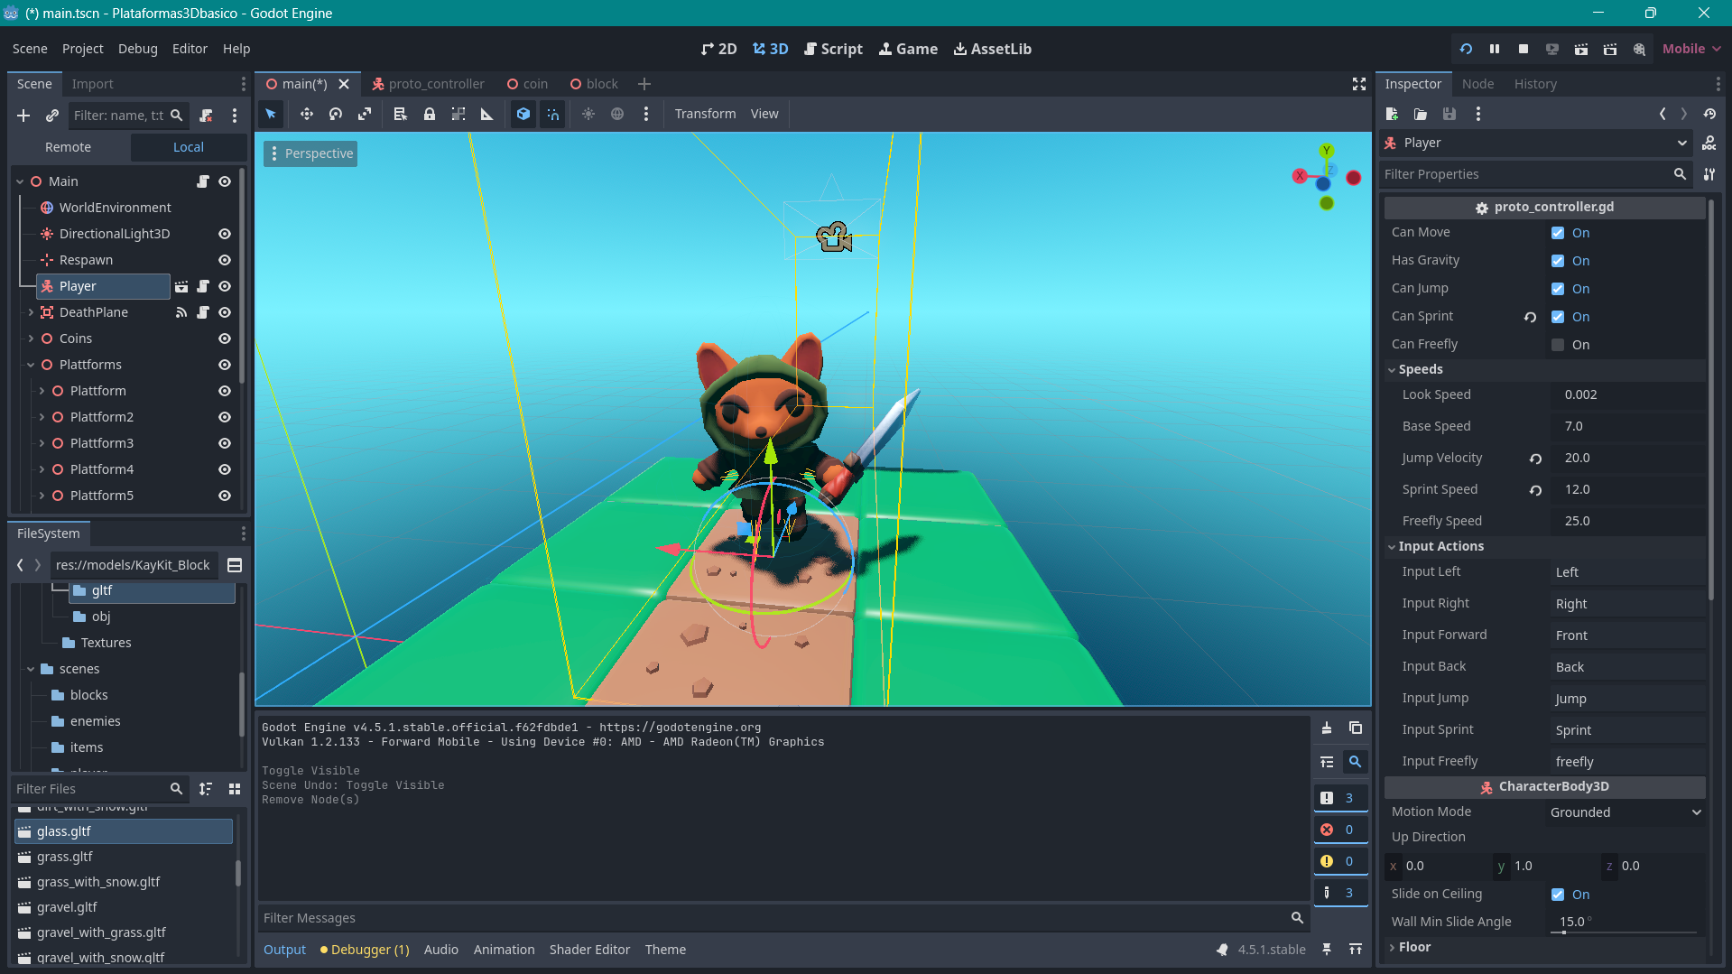

Jugador

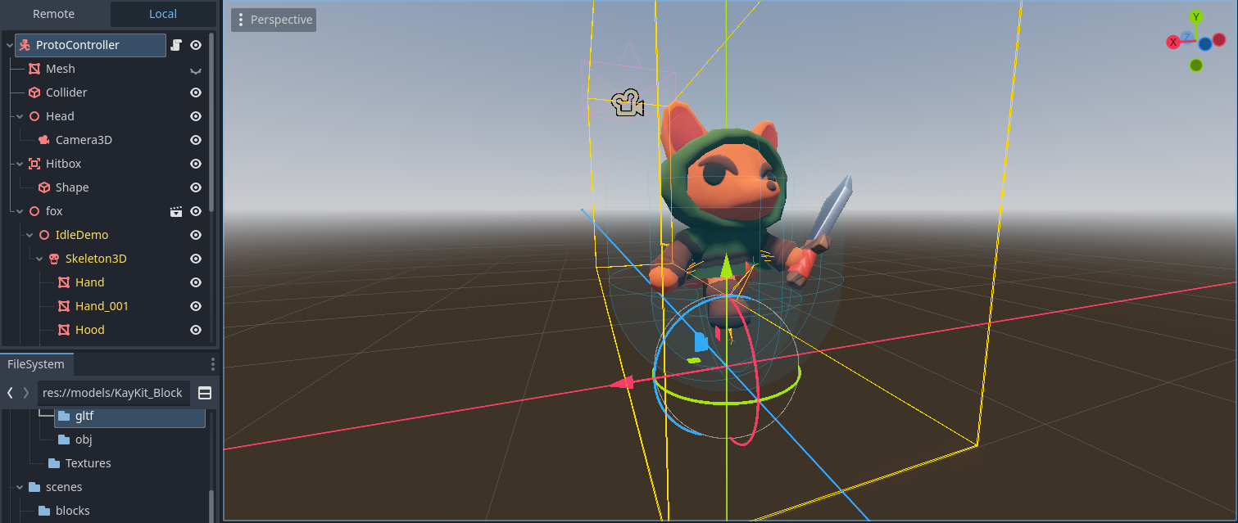

Escena del jugador

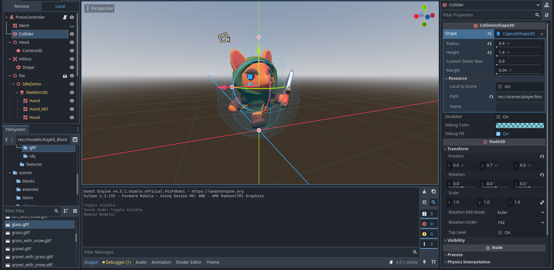

Colisión para terreno

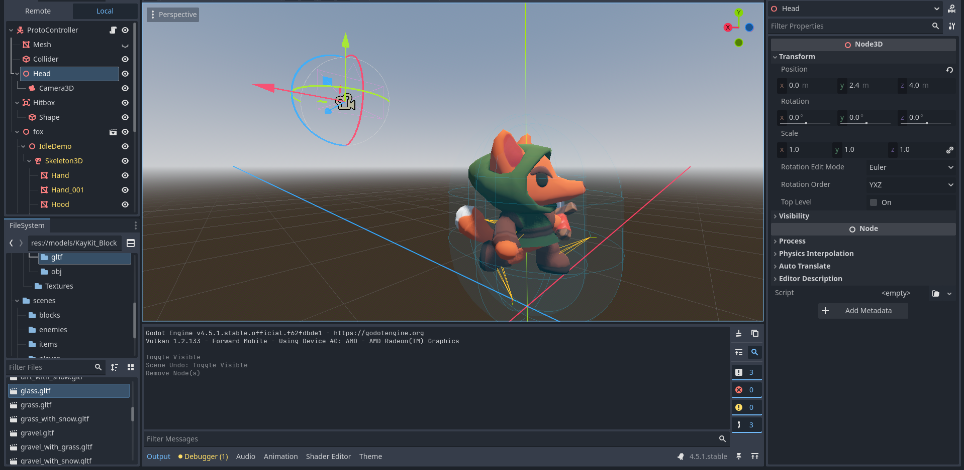

Cámara ajustada a cierta distancia del jugador

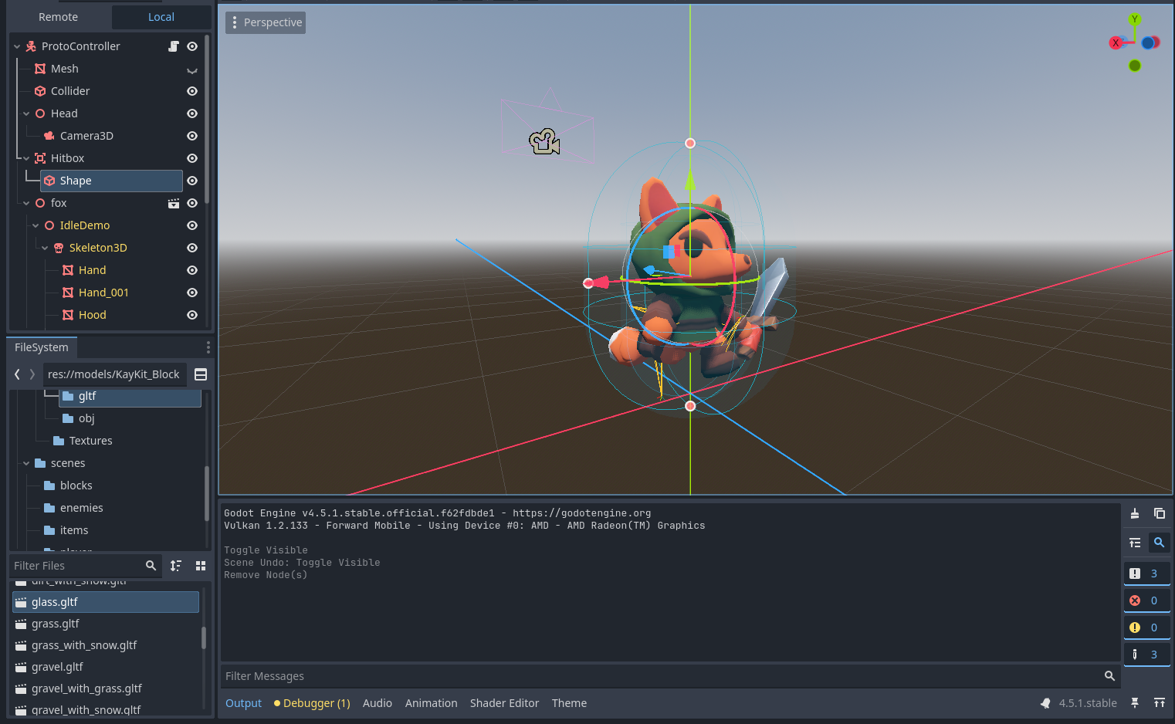

Colisión para monedas

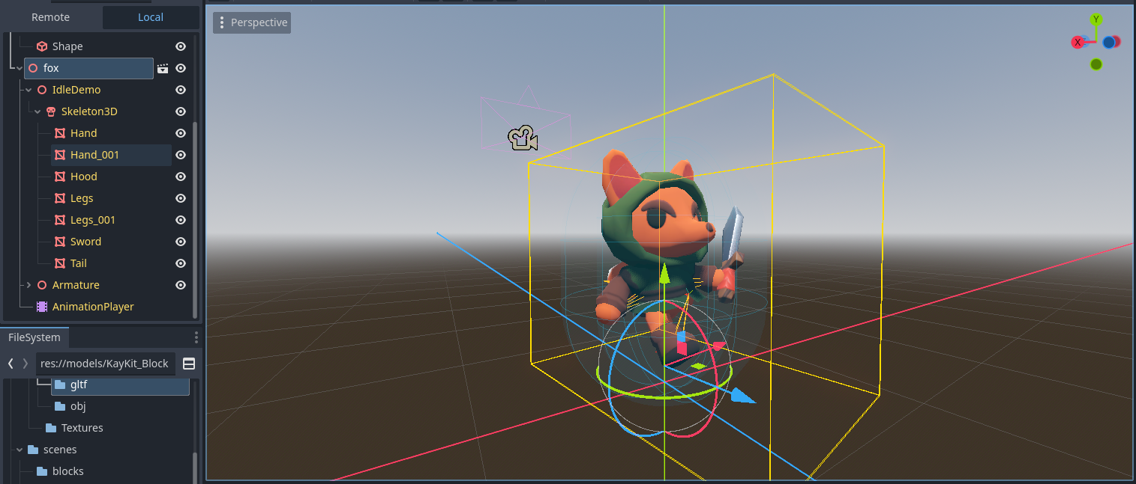

Modelo importado con meshes, texturas y animaciones

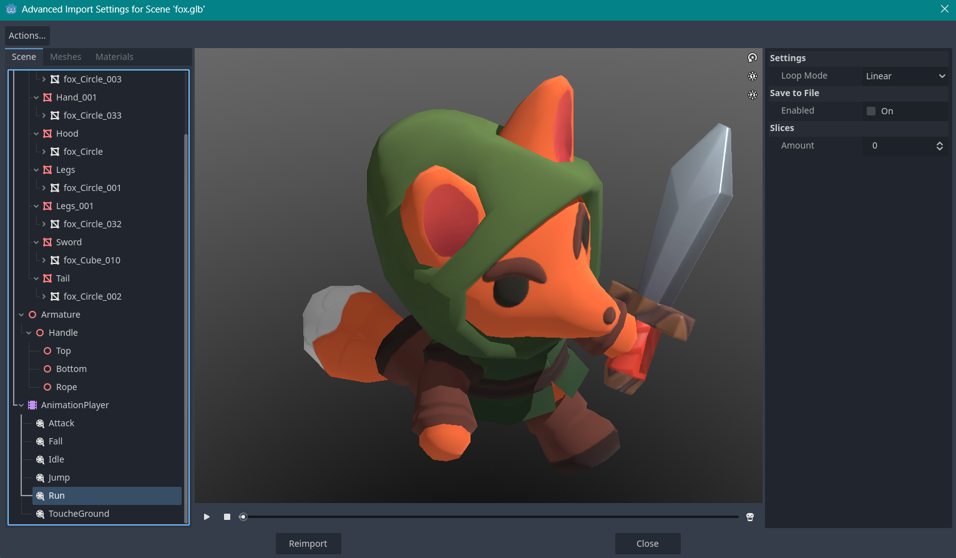

Animaciones adaptadas para loopear

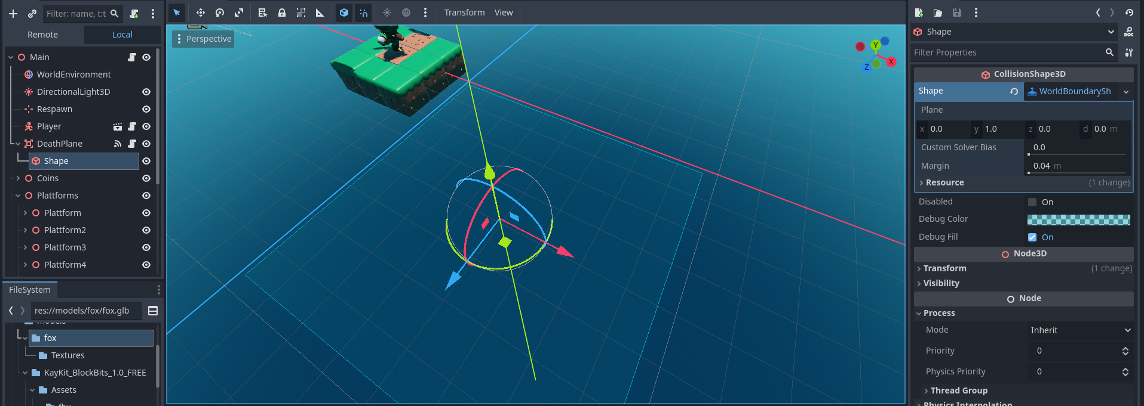

Plano para detectar caida y regresar al respawn

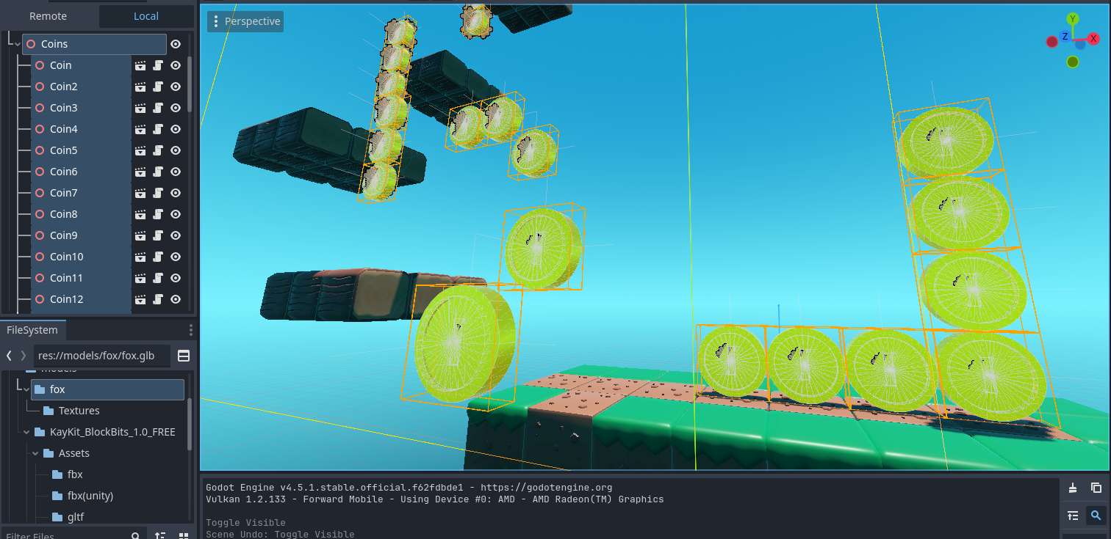

Monedas esparcidas por el nivel

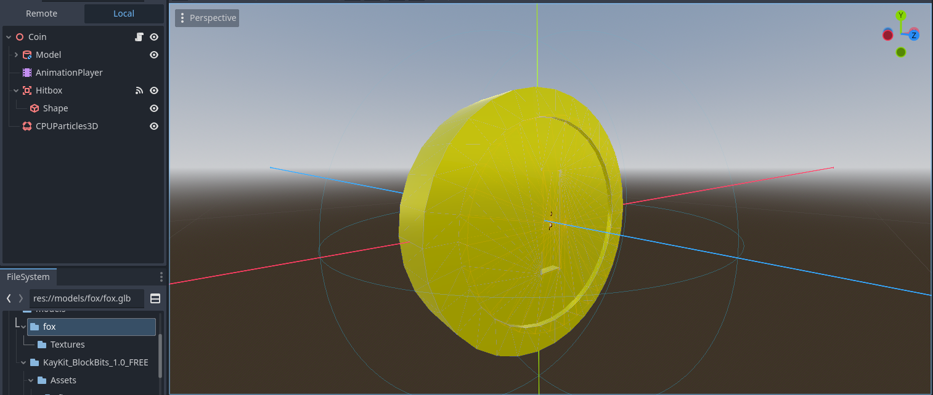

Escena de moneda

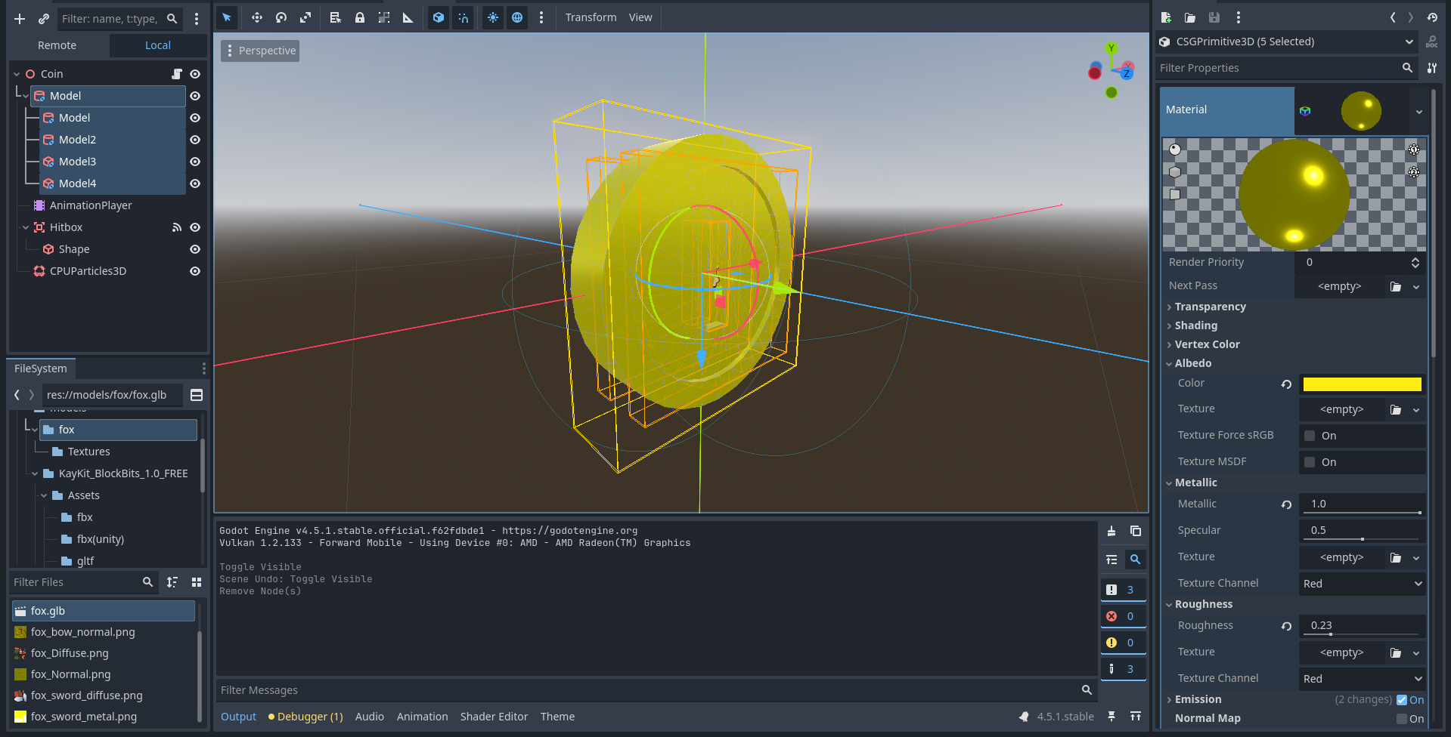

Modelo de moneda creado con nodos CSG

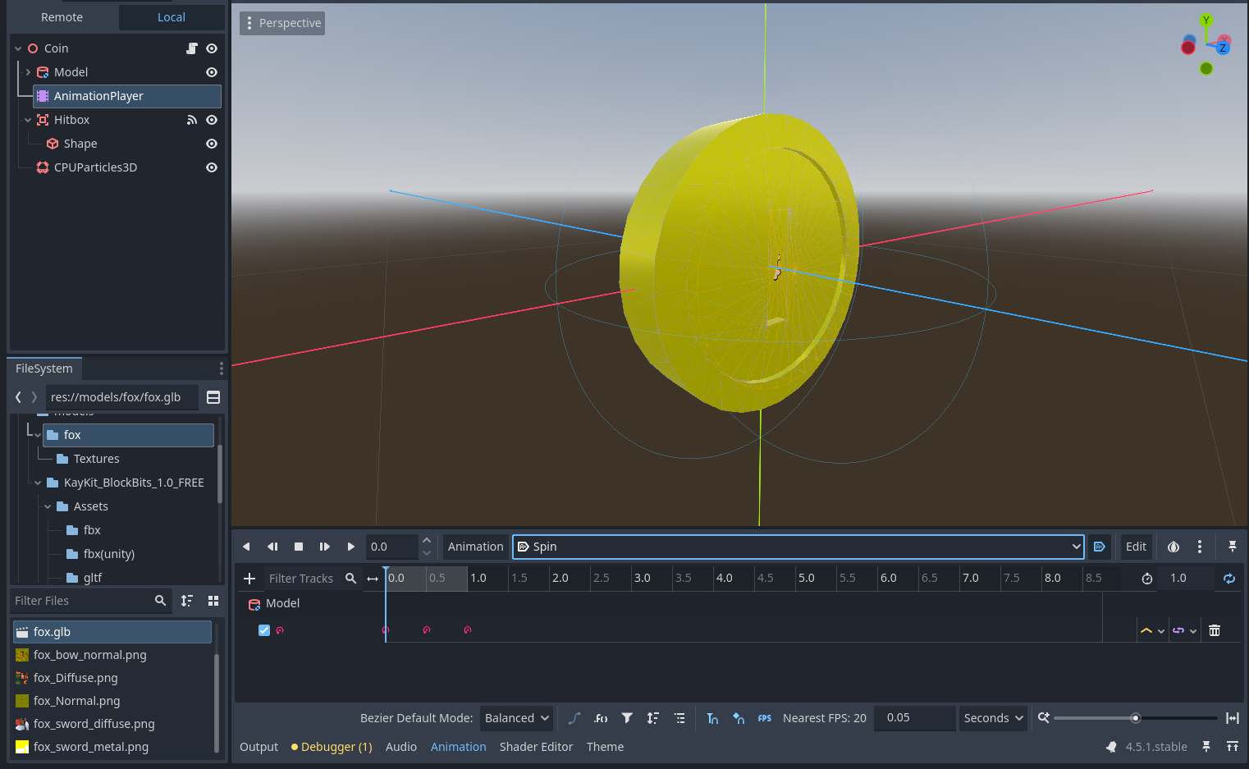

Animación para hacer girar la moneda

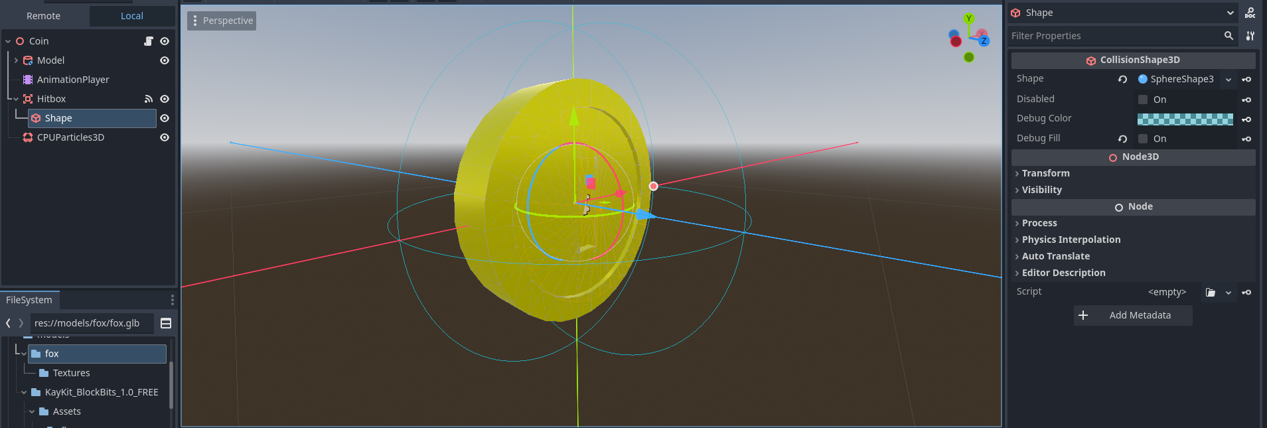

Colisión para ser recolectada

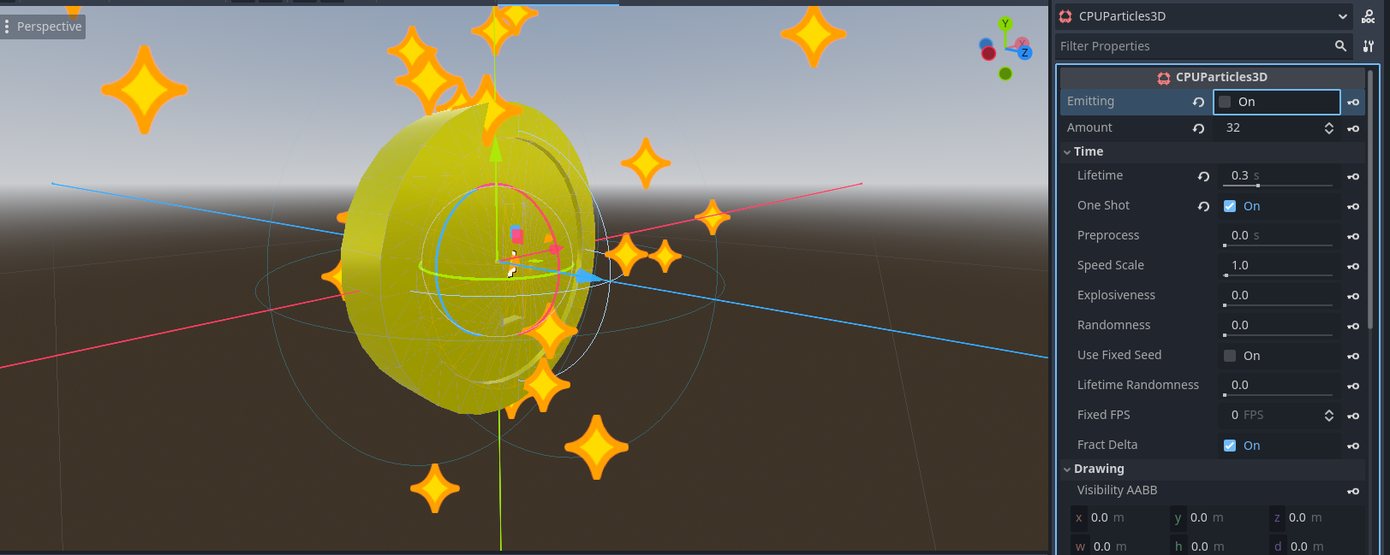

Partículas al ser recolectada

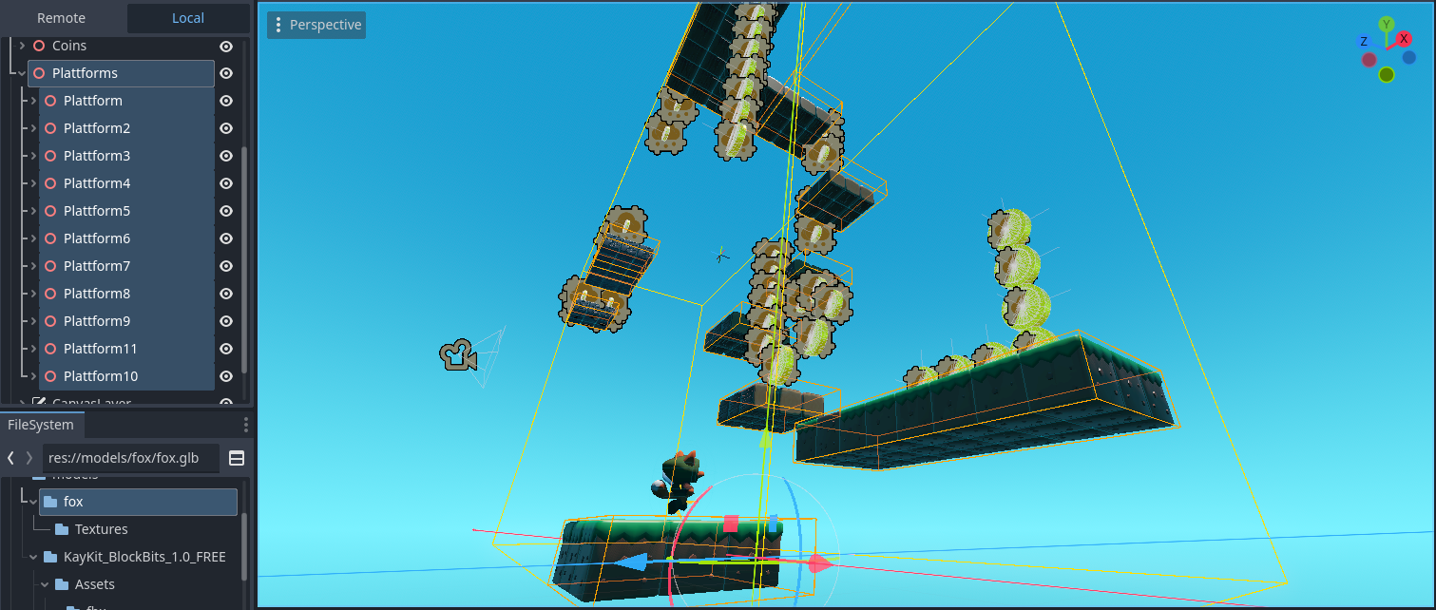

Grupos de plataformas repartidas por el nivel

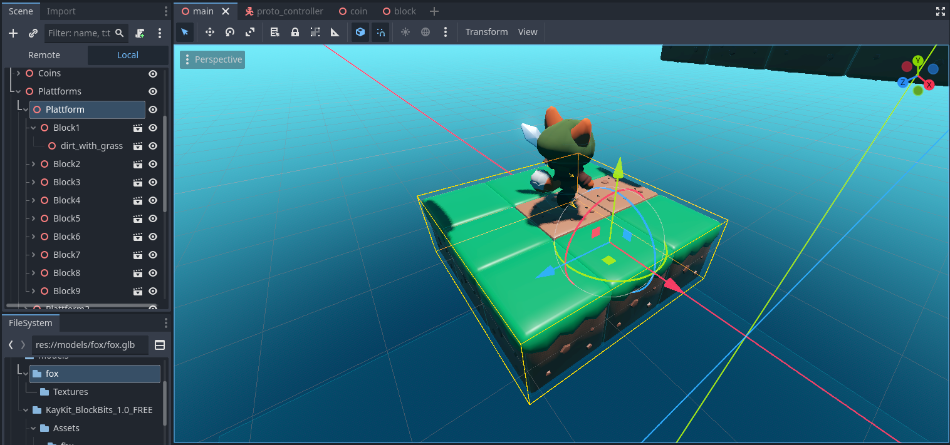

Grupo de bloques que forman las plataformas

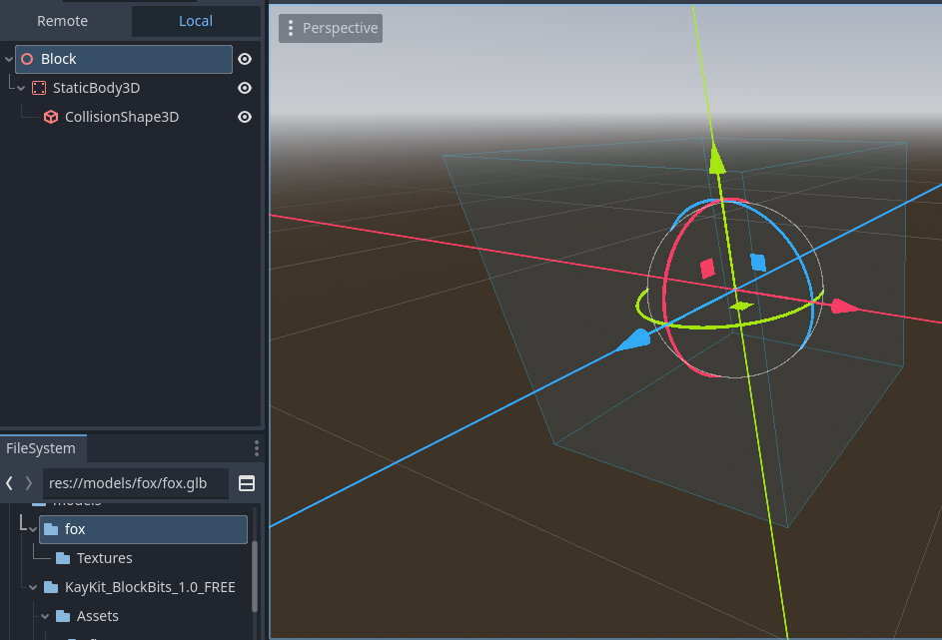

Escena que sirve como base para los bloques con colisión

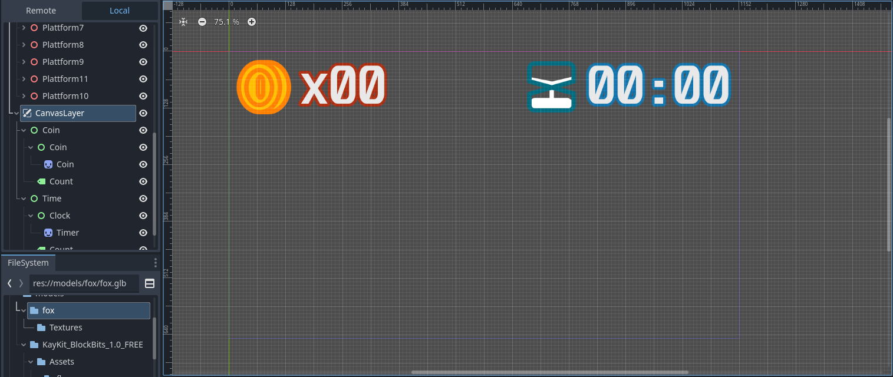

Interfaz de usuario

## Código

Código para manejar al jugador descargado del video de referencia

El manejo de cámara fue editado para cambiar a vista en tercera persona

Se agregaron triggers para las animaciones del modelo 3D

Se sustituyeron las acciones para usar inputs personalizados

|  |
| --- |
| # ProtoController v1.0 by Brackeys  # CC0 License  # Intended for rapid prototyping of first-person games.  # Happy prototyping!  extends CharacterBody3D  ## Can we move around?  @export var can_move : bool = true  ## Are we affected by gravity?  @export var has_gravity : bool = true  ## Can we press to jump?  @export var can_jump : bool = true  ## Can we hold to run?  @export var can_sprint : bool = false  ## Can we press to enter freefly mode (noclip)?  @export var can_freefly : bool = false  @export_group("Speeds")  ## Look around rotation speed.  @export var look_speed : float = 0.002  ## Normal speed.  @export var base_speed : float = 7.0  ## Speed of jump.  @export var jump_velocity : float = 4.5  ## How fast do we run?  @export var sprint_speed : float = 10.0  ## How fast do we freefly?  @export var freefly_speed : float = 25.0  @export_group("Input Actions")  ## Name of Input Action to move Left.  @export var input_left : String = "Left"  ## Name of Input Action to move Right.  @export var input_right : String = "Right"  ## Name of Input Action to move Forward.  @export var input_forward : String = "Front"  ## Name of Input Action to move Backward.  @export var input_back : String = "Back"  ## Name of Input Action to Jump.  @export var input_jump : String = "Jump"  ## Name of Input Action to Sprint.  @export var input_sprint : String = "Sprint"  ## Name of Input Action to toggle freefly mode.  @export var input_freefly : String = "freefly"  var mouse_captured : bool = false  var look_rotation : Vector2  var move_speed : float = 0.0  var freeflying : bool = false  ## IMPORTANT REFERENCES  @onready var head: Node3D = $Head  @onready var collider: CollisionShape3D = $Collider  @onready var anim: AnimationPlayer = $fox/AnimationPlayer  func _ready() -> void:  capture_mouse()  check_input_mappings()  look_rotation.y = rotation.y  look_rotation.x = head.rotation.x  func _unhandled_input(event: InputEvent) -> void:  # Mouse capturing  if Input.is_mouse_button_pressed(MOUSE_BUTTON_LEFT):  capture_mouse()  if Input.is_key_pressed(KEY_ESCAPE):  release_mouse()    # Look around  if mouse_captured and event is InputEventMouseMotion:  rotate_look(event.relative)    # Toggle freefly mode  if can_freefly and Input.is_action_just_pressed(input_freefly):  if not freeflying:  enable_freefly()  else:  disable_freefly()  func _physics_process(delta: float) -> void:  # If freeflying, handle freefly and nothing else  if can_freefly and freeflying:  var input_dir := Input.get_vector(input_left, input_right, input_forward, input_back)  var motion := (head.global_basis * Vector3(input_dir.x, 0, input_dir.y)).normalized()  motion *= freefly_speed * delta  move_and_collide(motion)  return    # Apply gravity to velocity  if has_gravity:  if not is_on_floor():  velocity += get_gravity() * 5.0 * delta  # Apply jumping  if can_jump:  if Input.is_action_just_pressed(input_jump) and is_on_floor():  velocity.y = jump_velocity  anim.play("Jump")    # Modify speed based on sprinting  if can_sprint and Input.is_action_pressed(input_sprint):  move_speed = sprint_speed  else:  move_speed = base_speed    #if move_speed > 0.0:    # Apply desired movement to velocity  if can_move:  var input_dir := Input.get_vector(input_left, input_right, input_forward, input_back)  var move_dir := (transform.basis * Vector3(input_dir.x, 0, input_dir.y)).normalized()  if move_dir:  velocity.x = move_dir.x * move_speed  velocity.z = move_dir.z * move_speed  $fox.rotation.y = (input_dir*Vector2(-1, 1)).angle()-PI/2  if is_on_floor() and velocity.y <= 0.0: anim.play("Run")  if not is_on_floor() and anim.current_animation != "Jump": anim.play("Fall")  else:  velocity.x = move_toward(velocity.x, 0, move_speed)  velocity.z = move_toward(velocity.z, 0, move_speed)  if is_on_floor() and velocity.y <= 0.0: anim.play("Idle")  else:  velocity.x = 0  velocity.y = 0    #if not is_on_floor() and anim.animation_finished:  #anim.play("Jump")    # Use velocity to actually move  move_and_slide()  ## Rotate us to look around.  ## Base of controller rotates around y (left/right). Head rotates around x (up/down).  ## Modifies look_rotation based on rot_input, then resets basis and rotates by look_rotation.  func rotate_look(rot_input : Vector2):  look_rotation.x -= rot_input.y * look_speed  look_rotation.x = clamp(look_rotation.x, deg_to_rad(-85), deg_to_rad(85))  look_rotation.y -= rot_input.x * look_speed  transform.basis = Basis()  rotate_y(look_rotation.y)  head.transform.basis = Basis()  head.rotate_x(look_rotation.x)  var percent = (rad_to_deg(head.rotation.x)+85)/170.0  head.position.z = 7.5 * (percent)  head.position.y = 8.0 * (1-percent) - 2.0  func enable_freefly():  collider.disabled = true  freeflying = true  velocity = Vector3.ZERO  func disable_freefly():  collider.disabled = false  freeflying = false  func capture_mouse():  Input.set_mouse_mode(Input.MOUSE_MODE_CAPTURED)  mouse_captured = true  func release_mouse():  Input.set_mouse_mode(Input.MOUSE_MODE_VISIBLE)  mouse_captured = false  ## Checks if some Input Actions haven't been created.  ## Disables functionality accordingly.  func check_input_mappings():  if can_move and not InputMap.has_action(input_left):  push_error("Movement disabled. No InputAction found for input_left: " + input_left)  can_move = false  if can_move and not InputMap.has_action(input_right):  push_error("Movement disabled. No InputAction found for input_right: " + input_right)  can_move = false  if can_move and not InputMap.has_action(input_forward):  push_error("Movement disabled. No InputAction found for input_forward: " + input_forward)  can_move = false  if can_move and not InputMap.has_action(input_back):  push_error("Movement disabled. No InputAction found for input_back: " + input_back)  can_move = false  if can_jump and not InputMap.has_action(input_jump):  push_error("Jumping disabled. No InputAction found for input_jump: " + input_jump)  can_jump = false  if can_sprint and not InputMap.has_action(input_sprint):  push_error("Sprinting disabled. No InputAction found for input_sprint: " + input_sprint)  can_sprint = false  if can_freefly and not InputMap.has_action(input_freefly):  push_error("Freefly disabled. No InputAction found for input_freefly: " + input_freefly)  can_freefly = false |

Código global que maneja los contadores

|  |
| --- |
| extends Node  var main  var coinCount  var timerCount  var coins = 0  var timer = 0  func _ready() -> void:  pass # Replace with function body.  func addCoins(qty = 1):  coins += qty  coinCount.text = str(coins).pad_zeros(2) |

Código del nodo principal que ayuda a que el nodo global maneje los contadores y actualice las interfaces

|  |
| --- |
| extends Node3D  func _ready() -> void:  Game.main = $"."  Game.coinCount = $CanvasLayer/Coin/Count  Game.timerCount = $CanvasLayer/Time/Count  func _process(_delta: float) -> void:  pass  func addSec():  Game.timer += 1  var time = Game.timer % 3600  Game.timer = time  var text = str(int(time)/60).pad_zeros(2)+":"+str(int(time)%60).pad_zeros(2)  $CanvasLayer/Time/Count.text = text |

Función que maneja la caída infinita

|  |
| --- |
| extends Area3D  func entered(_area: Area3D) -> void:  $"../Player".position = $"../Respawn".position |

Código de las monedas que inicializa la animación de obtención

|  |
| --- |
| extends Node3D  func entered(_area: Area3D) -> void:  Game.addCoins()  $AnimationPlayer.play("Collect") |

## Problemas y soluciones

Honestamente el desarrollo fue bastante sencillo y con pocos problemas, simplemente experimentar con lo que hacía cada parámetro me permitió entender como trabajar con cada uno de los elementos que conforman un juego en 3D, incluso muchas de las estructuras de las escenas resultaron ser paralelos casi exactos a las estructuras que he usado anteriormente en juegos 2D.